VPC Peering: -

A VPC peering connection is a networking connection between two VPCs

that enables you to route traffic between them using private IP addresses.

Step1:- By default one private VPC with ig and route table is available in your AWS account

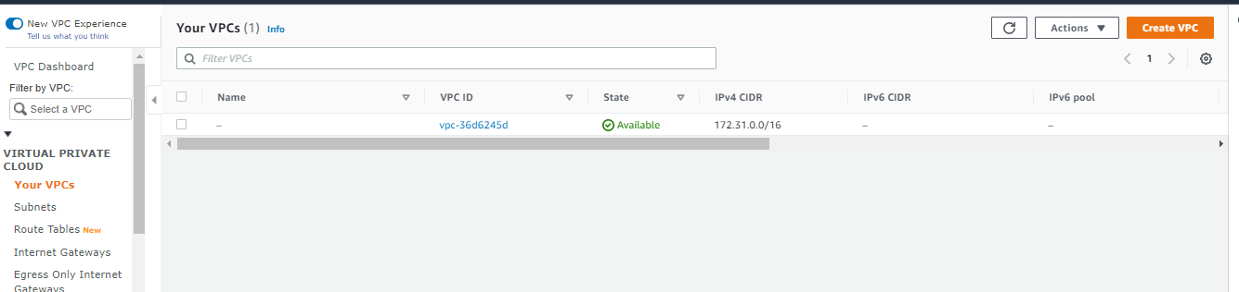

Step2: Create one private VPC in 192.168.0.0/16 range

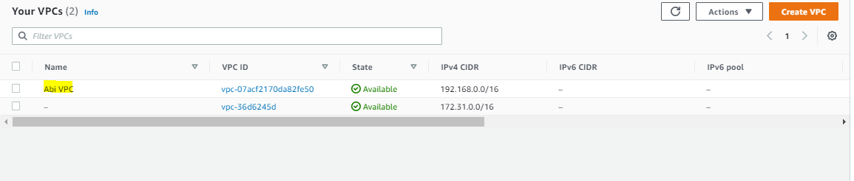

Step 3:- Create One Private Subnet in our Network 192.168.1.0/24

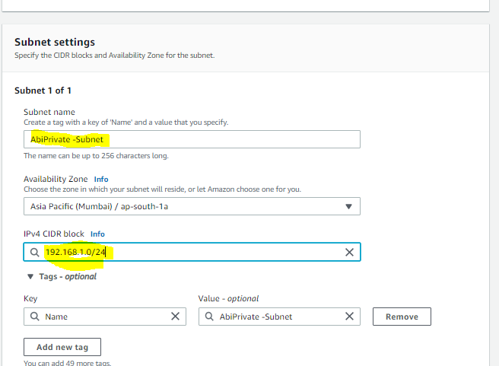

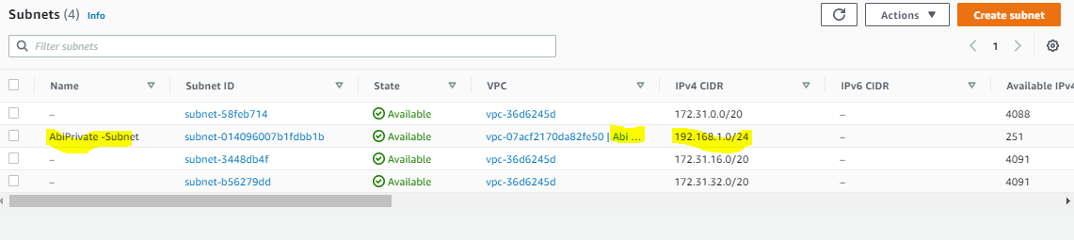

Step4:-Create one Internet GW and attach our VPC

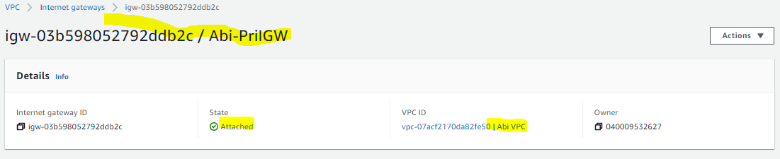

Step5:- Create a RT and add our Custom VPC

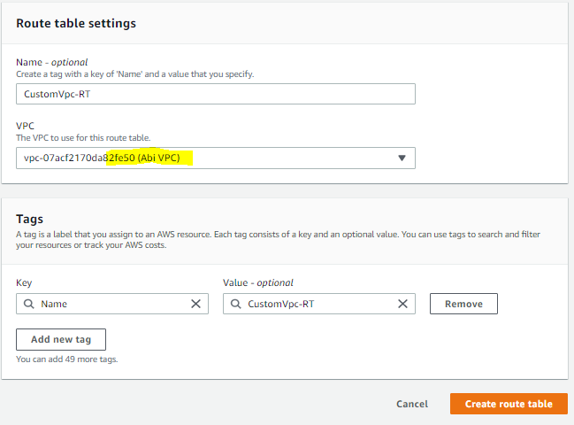

Step6:-Add the Routes and associate our subnet

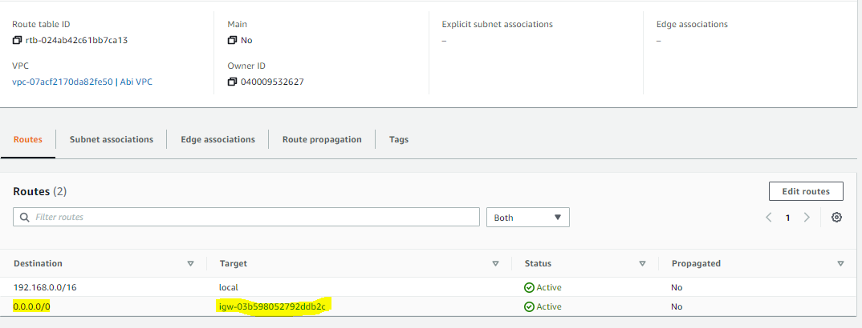

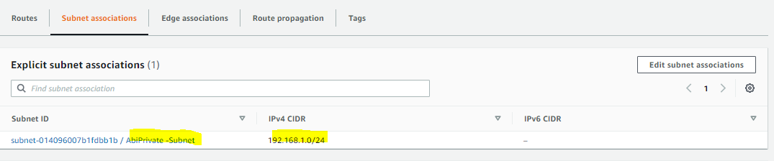

Step 7:Create 2 instance one in default VPC one in our Custom VPC (Disable public ip)allow all Traffic

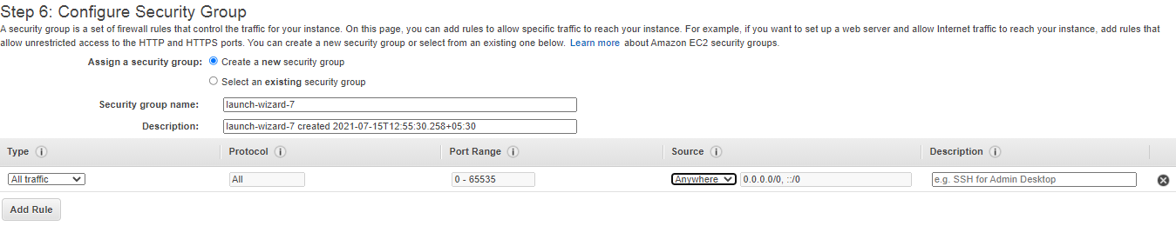

Step 8: Now Create Peering Connection Go to VPC Service 🡪Peering Connection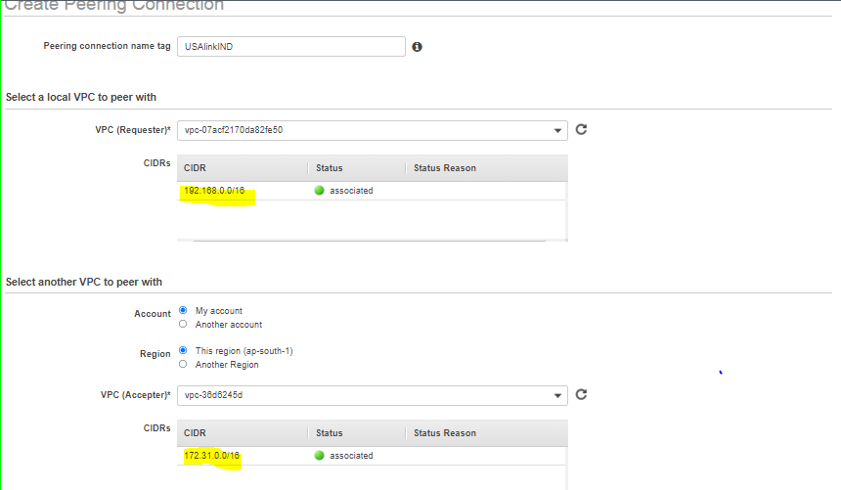

Step 9 And then Action---accept request--- accept the request

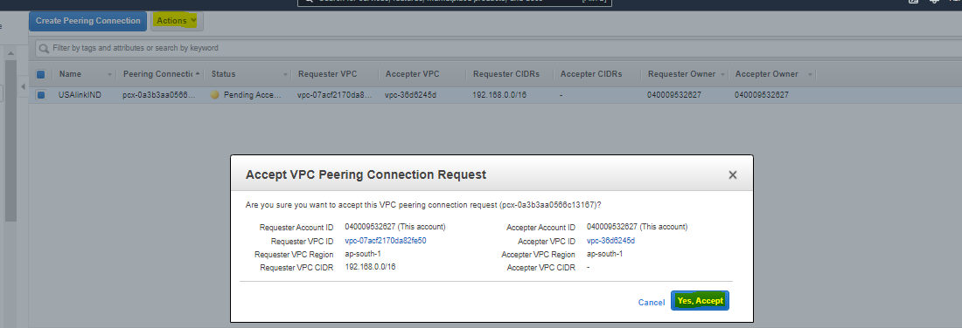

Note: Pending Status will goes to active

Step 10: Add 2 routes

One route in default Route table

Add route 192.168.0.0/16 to peer connection

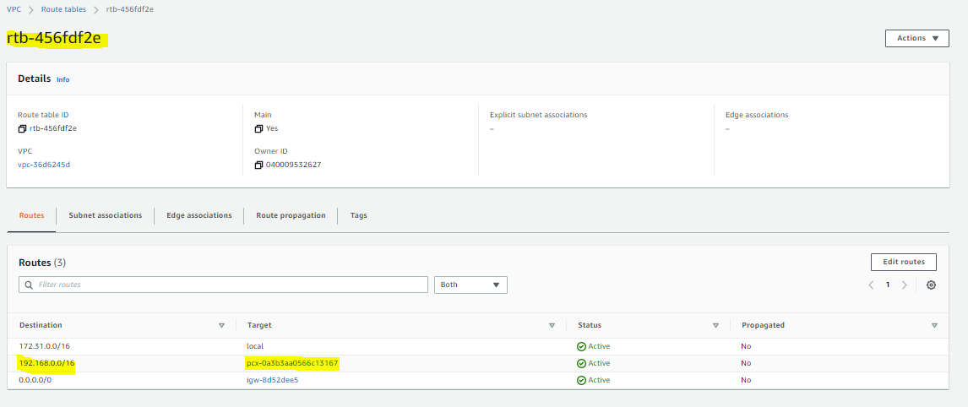

One route in CustomVPC-RT Route table ->Add route 172.31.0.0/16 to peer connection

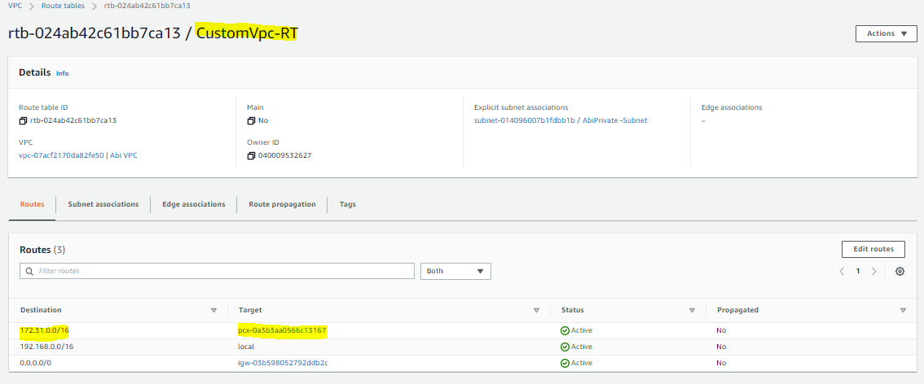

Step:11 Now try to login to Instance in default VPC using public IP

Try to get a ping response from PRIVATE IP in our Custom VPC

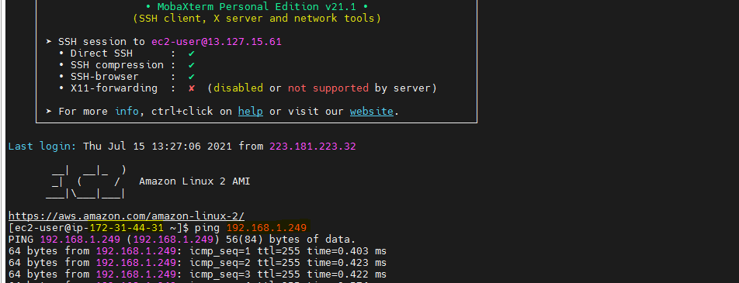

IT works ☺